**CSS COMPUTER EDUCATION**

**NKN COMPLEX,ESWARAN KOVIL BACK SIDE,**

**KARUR-1**

|  |  |  |  |  |
| --- | --- | --- | --- | --- |
| **S.NO** | **DATE** | **TALLY SYLLABUS** | **STUDENT SIGNATURE** | **STAFF SIGNATURE** |
| **1** |  | **INTRODUCTION ACCOUNTS** |  |  |
| **2** |  | **ACCOUNTS TYPES (GOLDEN RULES)** |  |  |
| **3** |  | **TRANSACTION,JOURNAL** |  |  |
| **4** |  | **COMPANY CREATION (SIMPLE)** |  |  |
| **5** |  | **LEDGER CREATION & GROUPS** |  |  |
| **6** |  | **VOUCHER (f4,f5,f6,f7,f8,f9)** |  |  |
| **7** |  | **BANK RECONCILATION STATEMENT** |  |  |
| **8** |  | **INVENTORY**   * **INVOICE,INVOICE WITH OPENING BALANCE,PRICE LIST,GODOWN, STANDARD & SELLING COST** |  |  |
| **9** |  | **ADDITIONAL COST OF PURCHASE** |  |  |
| **10** |  | **INTEREST CALCULATION** |  |  |
| **11** |  | **BUDGET & MAINTANANCE** |  |  |
| **12** |  | **MANUFACTURING & EXPIRE DATE** |  |  |
| **13** |  | **COMPANY CREATION (ADVANCED)**   * **SELECT COMPANY,SHUT COMPANY, ALTER COMPANY,DELETE COMPANY, GROUP, BACKUP & RESTORE, SPILT COMPANY,SECURITY CONTROL, CHANGE PASSWORD.** |  |  |
| **14** |  | **ORDER PROCESSING** |  |  |
| **15** |  | **DUTIES & TAXES**   * **VAT (VALUE ADDED TAX)** |  |  |
| **16** |  | **POINT OF SALES** |  |  |
| **17** |  | **PAY ROLL** |  |  |

TALLY ERP 9

===========

ERP - ENTERPRISE RESOURCE PLANNING

-NETWORK

in 1986 first introduced by bharat goenkar.

Tally Developed By Peutronious Pvt Ltd at Banglore in India.

Tally Programs are Written by TDL Language . Tally Developed Language.

Tally ERP 9 is already Defined set Program is called Package.

Tally is A Financial And Inventory Management System.

Tally is an Accounting Package.

Transfer of Money or Money's Worth from one place to another place is called accounts.

A Account having a Company or a Person is called Personal Account.

A Account Having Lot of Cash , Goods , Expenses , Income , Profit , Loss is called impersonal account**.**(real and nominal)

company : tally india pvt ltd, bangalore.

web: [www.tallysoultions.com](http://www.tallysoultions.com)

journal: collection of ledger from transaction

ledger: type of accounts(ex mani a/c, cash a/c, bank a/c)

types of accounts: or golden rules

=========================

1. personal account (ஆள்சார் கணக்கு) (கொடுக்கல் – வாங்கல்)

Debit the receiver – பெறுவோரை பற்று வை

Credit the giver - தருவோரை வரவு வை

E.g.: names, bank, name capital, …..

1. real account (சொத்து கணக்கு) (உள்ளே-வெளியே)

What comes in – debit (சொத்து உள்ளெ வந்தால் பற்று)

What goes out - credit (சொத்து வெளியே போனால் வரவு)

E.g.:

Cash, furniture, computer, ,sales goods, land,…

1. nominal account (பெயரளவு கணக்கு)(வரவு-செலவு)

All Expense & loses 🡪 debit

All Income, profit & gain🡪 credit

Eg: eb-bill, stationary, phone bill, courier, rent paid, rent recived,

salary paid,salary received,commission paid,commission received,wages..

**Groups :**

1. **Capital a/c :** capital, drawing.
2. **Direct expenses:** expenses in factory.

Eg: wages, carriage inward, maintenance charges (machine), manufacturing expenses, packing charges, fuel, trading expenses, freight charges, etc..,

1. **Indirect expenses:**  expenses in office & selling distribution.

Eg: carriage outward, depreciation, eb, telephone, advertisement, salary paid, rent paid,Internet bill, travelling charges, petrol, office exp stationary, postage, courier, parcel, discount paid, commission paid, conveyance, staff welfare(tea), insurance premium, petty expense, bank charges(dd commission), bonus, incentive, bad debts, etc..,

1. **Indirect income**: income

Eg: rent received, salary received, commission received, interest received, etc..,

1. **Asset:** 
   * 1. Current asset – eg: cash, debtors, stock in hand, etc..,
     2. Fixed asset – eg: - land, furniture, building, computer, ups, investment, fixed deposit.
     3. Intangible asset: eg: copy rights, good will, trade mark.
2. **Liability**

Eg: loan, bank loan, debenture, bank over draft, provision

1. **Purchase a/c:** Credit purchase, cash purchase, purchase return
2. **Sales a/c :** Credit sales, cash sales, sales return
3. **Sundry creditors :** suppliers.
4. **Sundry debtors :** receivers**.**
5. **Duties & taxes** : Sales Tax, VAT, Service Tax.
6. **Bank a/c :** Name of bank.
7. **Cash:** cash in hand (default)

**Eg: cash, petty cash**

1. **Profit and loss:** primary (default)

**Company creation:**

* Press **ALT+ F3 from** gateway of tally
* Enter create company

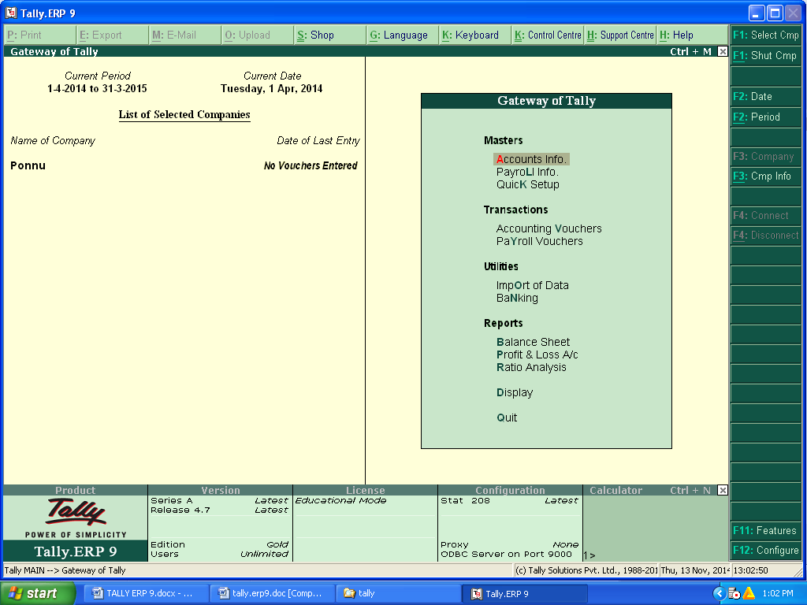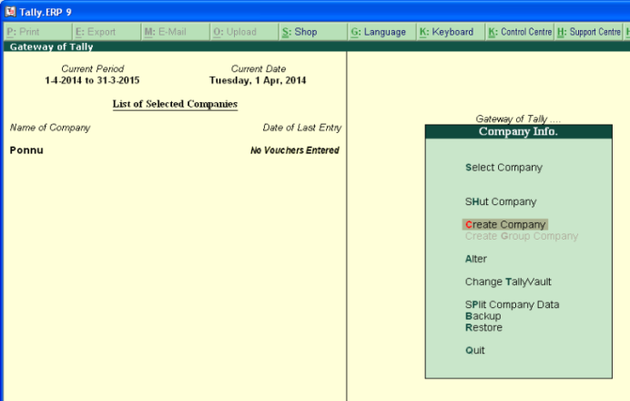

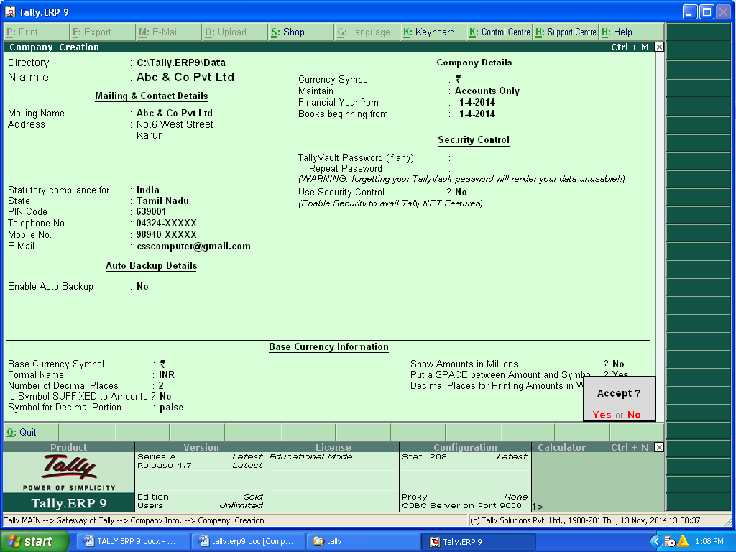

**Problems 1. Prepare Final A\C From Following Trial Balance:**

|  |  |  |
| --- | --- | --- |
| **Particulars** | **Debit (Rs)** | **Credit (Rs)** |
| Capital |  | 50000 |
| Sales |  | 25000 |
| Creditors |  | 5000 |
| Loan From Uco Bank |  | 10000 |
| Commission Received |  | 2000 |
| Rent Received |  | 4000 |
| Purchase | 10000 |  |
| Wages | 1500 |  |
| Carriage Inward | 200 |  |
| Salary | 2500 |  |
| Telephone Charges | 1000 |  |
| Electricity Charges | 850 |  |
| Advertisement Charges | 1250 |  |
| Land & Building | 40000 |  |
| Furniture | 5000 |  |
| Debtors | 20300 |  |
| Cash | 13400 |  |
| TOTAL | 96000 | 96000 |

REPORT: BALANCE SHEET, PROFIT & LOSS A\C, DISPLAY—TRIAL BALANCE.

**2. Prepare Final A\C From Final Following Trial Balance:**

|  |  |  |
| --- | --- | --- |
| **Particulars** | **Debit(Rs)** | **Credit(Rs)** |
| Capital |  | 100000 |
| Sales |  | 75000 |
| Creditors |  | 35000 |
| Loan From Uco Bank |  | 10000 |
| Commission Received |  | 4000 |
| Rent Received |  | 2000 |
| Purchase | 50000 |  |
| Wages | 1500 |  |
| Carriage Inward | 200 |  |
| Salary | 1000 |  |
| Telephone Charges | 2500 |  |
| Electricity Charges | 850 |  |
| Advertisement Charges | 1250 |  |
| Land & Building | 90000 |  |
| Furniture | 20000 |  |
| Computer | 25000 |  |
| Debtors | 13400 |  |
| Cash | 20300 |  |
| Total | 226000 | 226000 |

**REPORT: BALANCE SHEET, PROFIT & LOSS A\C, DISPLAY—TRIAL BALANCE.**

**3. Prepare Final A\C From The Following Trial Balance:**

|  |  |  |  |
| --- | --- | --- | --- |
| **Debit Balance** | **Rs** | **Credit Balance** | **Rs** |
| Cash Purchase | 100000 | Capital | 200000 |
| Credit Purchase | 5000 | Cash Sales | 7500 |
| Wages | 300 | Credit Sales | 35000 |
| Carriage In Ward | 200 | Return Outward | 500 |
| Manufacturing Exp | 500 | Commission Received | 1500 |
| Rent Paid | 1000 | Interest on Investment | 2500 |
| Salaries | 2000 | Loan From IOB | 120000 |
| Insurance | 500 | Siva &co | 62560 |
| Advertisement charges | 560 |  |  |
| Ram & co | 30000 |  |  |
| Indian Bank | 50000 |  |  |
| Building | 100000 |  |  |
| Furniture | 45000 |  |  |
| Sri Ram Funds (Investments) | 15000 |  |  |
| Postage | 2000 |  |  |
| Telephone Charges | 1800 |  |  |
| Return Inward | 700 |  |  |
| Cash | 75000 |  |  |
| **Total** | **429560** | **Total** | **429560** |

**4. Prepare Final A\C From The Final Balance:**

|  |  |  |  |
| --- | --- | --- | --- |
| **Debit Balance** | **Rs** | **Credit Balance** | **Rs** |
| Stock In Hand | 25000 | Capital | 400000 |
| Purchase | 50000 | Loans | 150000 |
| Freight | 500 | SS & co | 75000 |
| Wages | 1000 | Profit & Loss A\C | 25000 |
| Building | 450000 | Debenture | 50000 |
| Cash | 56000 | Sales | 75000 |
| IOB A\C | 100000 | Commission | 2000 |
| Salary | 5000 |  |  |
| E.B Bill | 2000 |  |  |
| Advertisement Charges | 1400 |  |  |
| Insurance | 2100 |  |  |
| Furniture | 84000 |  |  |
| **Total** | **777000** | **Total** | **777000** |

**5. From the Following Trial Balance To prepare The Final A\C**

|  |  |  |  |
| --- | --- | --- | --- |
| **Debit Balance** | **Rs** | **Credit Balance** | **Rs** |
| Cash Purchase | 50000 | Capital | 150000 |
| Credit Purchase | 75000 | Cash Sales | 45000 |
| Wages | 5000 | Credit Sales | 75000 |
| Carriage In Ward | 2000 | Return Outward | 5000 |
| Manufacturing Exp | 4500 | Commission Received | 6000 |
| Rent Paid | 5000 | Discount | 1000 |
| Salaries | 10000 | Loan From IOB | 46750 |
| Advertisement charges | 7000 | Debenture | 75000 |
| Cash | 50000 | Arun & co | 75000 |
| Vimal & Co | 75000 |  |  |
| State Bank of India | 65000 |  |  |
| Furniture | 25000 |  |  |
| Building | 80000 |  |  |
| Gm Fund (Investments) | 10000 |  |  |
| Telephone Charges | 2500 |  |  |
| Return Inward | 7000 |  |  |
| Petty | 1250 |  |  |
| Postage | 500 |  |  |
| Insurance | 4000 |  |  |
| **Total** | **478750** | **Total** | **478750** |

**Introduction for Vouchers**

**Main Vouchers (6)**

1. Contra ( F4 )

* + - * + Bank transaction ( Deposit , Withdraw )

2. Payment ( F5 )

* + - * + Paid to Sundry creditors ( Cash or Cheque )
        + Paid to Petty expenses
        + Paid to any Other expenses ( Direct or Indirect expenses)
        + Payment made by purchase of Fixed Asset

( Cash or Cheque ).

3. Receipt ( F6 )

* + - * + Received from Sundry debtors ( Cash or Cheque )
        + Received as Capital
        + Received from any Other incomes
        + Received from sale of Fixed Asset ( Cash or Cheque ).

4. Journal ( F7 )

* + Sales return & Purchase return.
  + All Adjustment (Depreciation , Advanced , Prepaid , Accured, Incurred , Outstanding , Bad debt …)

5. Sales (F8)

* + - * + Cash Sales.
        + Credit Sales.

6. Purchase (F9)

* + - * + Cash Purchase
        + Credit Purchase

**Vouchers**

**1. Prepare The Final A\C From The Following Entries:**

* Mani Has Started a Business with Capital of Rs.500000

* Deposited Into Sbi Bank Rs. 100000

* Purchase Goods from MRS&Co Rs.150000 on Credit

* Bought a Furniture Rs.25000

* Cash Sales made during the month Rs.50000

* Sales to MM&Co Rs. 25000

* Goods returned to MRS&Co Rs. 6000

* Wages paid by cash Rs.500

* Salaries paid by cheque Rs.2500 (Cheque No: 854500)

* Goods return from MM&Co Rs.2000

* Paid to MRS&Co by cheque Rs. 75000(Cheque No: 74542)

* Received from MM&Co by cash Rs. 20000

* Telephone Charges Paid Rs.1500

* Petty expenses Rs. 500

answer: 6,50,000

1. **Prepare The Final A\C From The Following Entries:**

* Arun Has Started a Business with a capital Rs. 700000

* Deposited into KVB bank Rs. 200000

* Purchase Goods from GV&Co Rs.195000 on Credit

* Bought a furniture Rs. 60000

* Cash Sales made during the month Rs.175000

* Sales to JKR & Co Rs.45000

* Goods return to GV&Co Rs.10000

* Wages paid by cash Rs.500

* Salaries Paid by cheque Rs. 2500

* Goods Return from JKR&Co Rs. 5000

* Paid to GV&Co Cheque 70000

* Received from JKR&Co by cash Rs.2000 0

* Telephone Charges Paid Rs. 1500

* Petty Expenses Paid Rs. 500

* Advertisement Charges Paid Rs. 5000

* Electricity Charges Paid Rs. 1800

* Cash Withdrawn from bank Rs.50000

**ans:10,45,000**

**3. Journalize the following transactions:**

* Rama commenced business with Capital of Rs. 100000

* Opened Current Account in the Indian Bank Rs. 60000

* Purchase goods from Lakshman Rs. 40000

* Sold Goods to Bharathan Rs. 55000

* Bought  2 tables and three Chairs Rs. 25000

* Returned Goods to Lakshman Rs.5000

* Purchased Paper, ink and pencil Rs.250

* Paid to Lakshman Rs. 35000 by cheque

* Bharathan paid us Rs. 52800

* Cash sales Rs. 50000

* Bought goods from Gopal Rs. 30000

* Sales to Liberty Emporium Rs.60000

* Cash Purchase Rs.20000

* Returned goods to Gopal Rs. 2000

* Paid to Gopal by cheque Rs. 20000

* Received cheque from Liberty Emporium Rs. 57500

* Drawings Rs .25000

* Sold goods to Anand as well as Cash received Rs.65000

* Paid to rent Rs. 15000 by cheque

* Paid for Salary RS. 20000

**ans: 3,45,0000**

**4. Journalize the following transactions:**

* Arul Commenced business with Capital of Rs.210000.

* Deposited in to Bank Of Baroda Rs. 100000

* Bought goods for cash Rs. 92000.

* Sold goods to kannan on credit Rs. 56000

* Purchase goods from Mani Rs. 33000

* Received Cash from Kannan Rs. 36000

* Paid to Mani on account Rs. 21000

* Sold goods to Manohar Rs. 35000

* Cash Sales Rs.75000

* Paid to Mani Rs. 12000

* Received cash from Manohar Rs. 35000

* Paid Rent Rs. 4500

* Paid Salaries to office staff Rs. 17000

**ans: 3,76,000**

**5. Journalize the following transactions:**

* Madhu commenced business with Capital of Rs.1000000.
* Deposited in to Bank of India Rs.50000
* Bought a Computer for Rs.20000
* Purchase goods from ABC & Co for Rs.100000
* Purchase goods from Akshaya & Co for Rs.5000 on cash
* Sales goods to Vaisali & Co for Rs.200000
* Cash sales for Rs.100000
* Goods return to ABC & Co for Rs.5000
* Telephone charges for Rs.2000
* E B bill for Rs.3000
* Goods return from Vaisali & Co Rs.3000
* Salary paid for Rs.10000 as cheque
* Wages paid for Rs.3000 as cash
* Paid Rs.50000 to ABC & Co as cheque
* Received Rs.150000 as cash from Vaisali & Co
* Commission received for Rs.8000
* Rent received from Rs.6000 as cheque
* Discount received for Rs.7000
* Bad debts arise from Vaisali & Co Rs.2000
* Outstanding salary for Rs.1000

**ans: 13,76,000**

**BRS - BANK RECONCILIATION STATEMENT**

MEANING: Bank Passbook Deposit/Withdraw/Balance Information.

Question:

capital received by cash Rs. 100000

cash deposited in SBI Rs. 50000

deposit slip: (sundry deptors)

sanjay & co Rs. 25000(cheque no. : 52368)

kiran & co Rs. 45000 (cheque no. : 52345)

asha & co Rs. 20000 (cheque no. : 72354)

krian & co Rs. 20000(cheque no. : 95845)

asha & co Rs. 15000(cheque no. :40050)

counter foils: (sundry creditors)

geetha & co Rs. 15000( ch no: 79877)

sachin & co Rs. 5000 ( ch no: 54523)

arthi & co Rs. 7500 (ch.no : 41224)

sachin & co Rs. 10000 (ch.no: 85522)

Geetha & co Rs. 12000( ch.no: 45521)

bank charges paid Rs. 250.

**Inventory (stock maintenance)**

Purchase items

Sales items

Balance items

**Standard cost and selling cost**

Meaning: it is used to fix rate purchase items and selling items.

Question:

Inventory:

Purchase from raman

Fridge 75 no’s Rs. 11,000/nos

Tv 100 nos’s Rs. 12,000/nos

Sales to kumaran

Fridge 10 no’s Rs.15000/nos

Tv 25 nos’s Rs. 14,500/nos

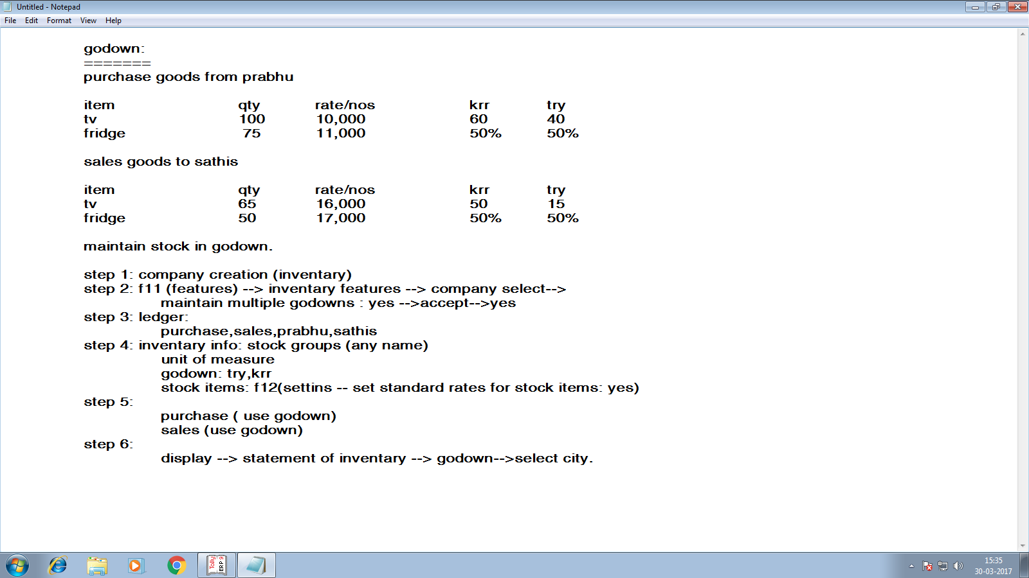

expiry date: or batchwise

==================

question:

=========

batchwise details

purchase from bhava medicals

|  |
| --- |
| item nos price MED exp.d |
| kalpal 50 2.00 1/7/2014 1/12/14 |
| Vicks  action 500 35 1.50 1/4/14 1/11/14 |
| digene 40 0.50 1/2/14 1/10/14 |
| paracitamol 45 2 1/5/14 1/11/14 |

sales to sena medicals

item nos price batchno

kalpal 35 3 kpo11

vicks action

500 25 2.50 vk412

digene 34 1 dd675

paracitamol 40 3 pc345

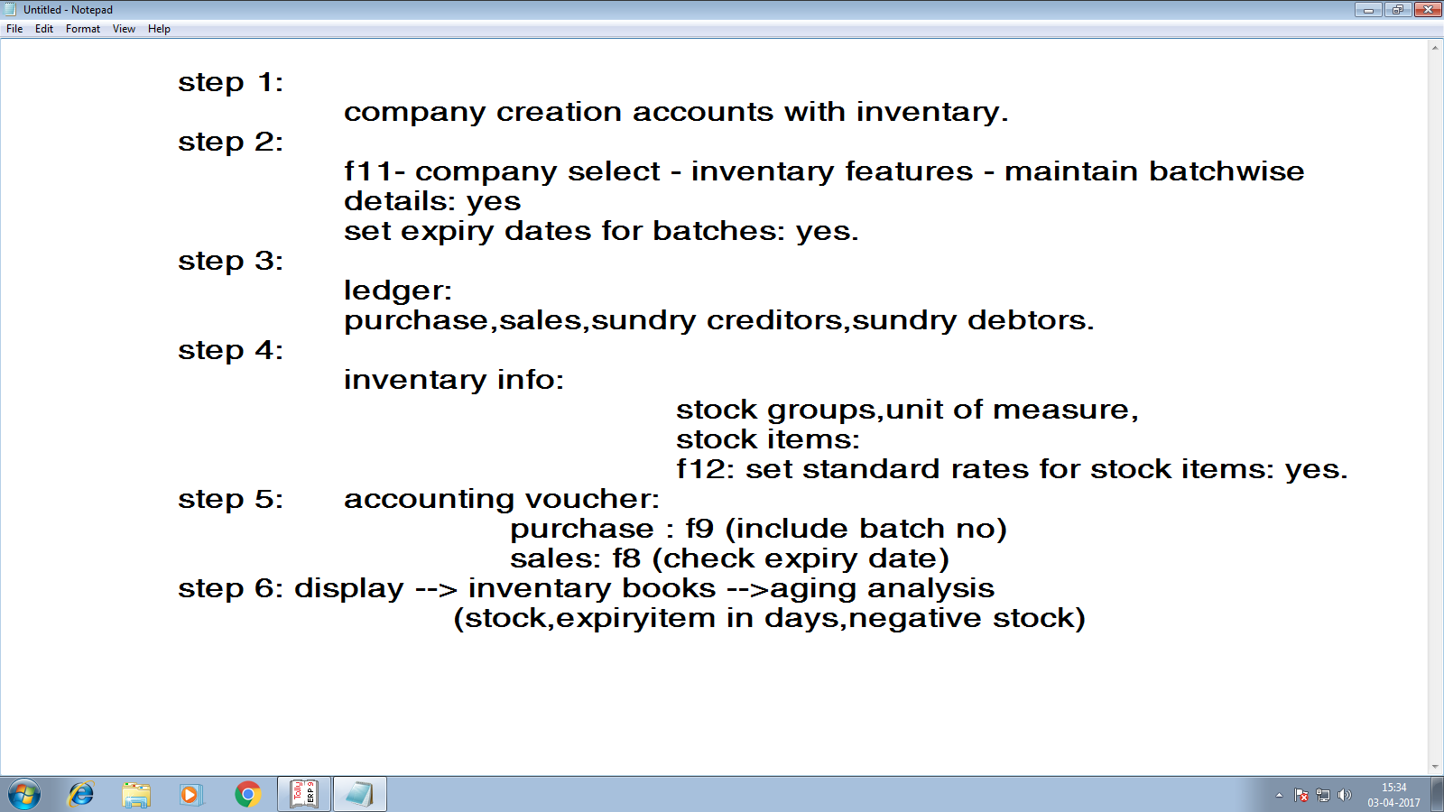

**KISHORE ELECTRICALS Started a Business of Electrical Items And Home appliances**

1. Received Capital By Cash Rs.20, 00,000.

2. Cash deposited into SBI Rs. 2, 00,000.

3. Credit Purchase from Vasanth Electrical (Bill No: 456).

LG Colour TV – 100 Nos @ Rs. 7000.

Washing Machine – 100 Nos @ Rs. 6500.

Sony Radio – 100 Nos @ Rs. 1500.

4. Credit Sales to Kumar Traders (Bill No: 859):

LG Colour TV – 70 Nos @ Rs. 7750.

Washing Machine – 50 Nos @ Rs. 7000.

Sony Radio – 70 Nos @ Rs.2500.

5. Cash Sales - (Bill No: 786):

Each Item – 15 Nos.

(-) Cash discount 5%.

6. Paid Cheque to Vasanth Electrical Rs. 8, 00,000.

7. Received Cheque from Kumar Traders Rs. 7, 50,000.

8. Paid petty Cash Rs. 2000.

9. Payment made by Cash:

Furniture Rs. 15000

Salaries Rs. 10000

Wages Rs. 7000

Carriage Inwards Rs . 1500

1. Payment made by petty cash:

Postage Rs. 250

Stationeries Rs. 200

Staff Welfare Rs. 150

1. Provide 10% depreciation on furniture.

Report: (1.) Display—Statement of Inventory, Inventory Book. (2.) Stock summary.

**answer : trial balance: 40,26,250/-**

**ADDITIONAL COST OF PURCHASE**

NOTE:

* + Model -1 Inventory Affected
  + Model -2 Groups Affected
  + Model - 3 Features Affected

**PROBLEM:**

1. Capital Received By Cash Rs.500000

2. Cash deposited in ICICI bank Rs.200000

3. Purchase from JOHNSON & JOHNSON

500 Nos of Baby oil @ Rs.50

Octori duty 4%

Packing Rs.500

Carriage Rs.700

4. Purchase from JOHNSON & JOHNSON

500 Nos of Baby Soaps @ Rs.20

Octori duty 4%

Packing Rs.700

Carriage Rs.1000

5. Purchase from JOHNSON & JOHNSON

200 NOS of Baby powder @ Rs.50

Octori duty 4%

Packing Rs.750

Carriage Rs.1250

**Report: Groups Alteration and Stock Summary**

**Payroll (salary bill)**

Employee - worker

Employer - owner

Basic salary –

Hra

Ma

Ta

Da – dearness allowance (incentive)

Esi – employee service insurance

Pf – provident fund

Bonus

OT – Over Time

**VAT- VALUE ADDED TAXES**

Published by manmohan singh 1998

Pay the VAT to Govt. Purchase goods or sales goods .

5 parts of vat %

0 % = food items ( 1 - day)

1% = gold, silver

4% =dress,rice

12.5% = electrical items

14.5% = petrol , diesel

Input vat: purchase

Output vat: sales

**Question:**

1.4.2014 on sales to mani

Computer 100 nos Rs. 15,000(12.5%)

Rice 50 nos Rs. 150 (4%)

Tv 100 nos Rs. 10000(12.5%)

Discount on sales 5% on total sales value.

Purchase from akber

Computer 150nos Rs. 10,000 (12.5%)

Rice 100 nos Rs. 120 (4%)

Tv 120 nos Rs. 7000(12.5%)

Calculate the VAT Details.

**Point Of Sales(POS)**

Meaing: bill book

Question:

Purchase from sakthi

Cpu 100 no’s 7500

Monitor 150 no’s 3000

Mouse 200 no’s 300

Sales to nisha

Cpu 75 no’s 10000

Monitor 100 no’s 4000

Mouse 50 no’s 500

Discount some -10%

Cash / cheque accepted on sales.